Preschool Lesson Plan
October 2013
Theme | Mon | Tue | Wed | Thu | Fri
Theme: “Animals in Fall”  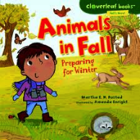 | Phonics- Letter Tt  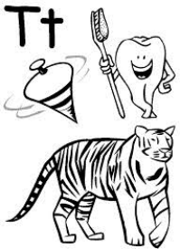 | 1  Arts & Crafts- Squirrel in a Tree  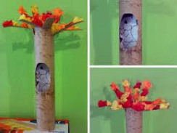 | 2  Math- Number 4  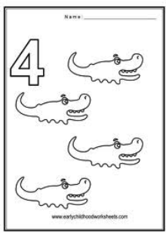 | 3  Science- “All About A Squirrel”  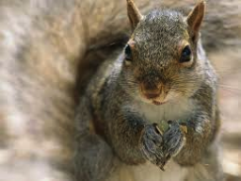 | 4  Art- Drawing  Music & Movement
Theme: “Healthy Me”  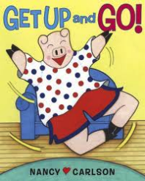 | 7  Phonics- Letter Vv  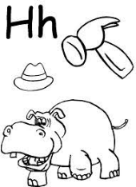 | 8  Arts & Crafts-  Collage “Healthy Foods”  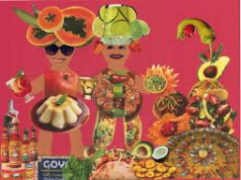 | 9  Math- Number 5  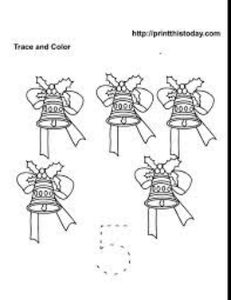 | 10  Science- Foods and exercise help the body grow   | 11  Art- Drawing  Music & Movement
Theme: “Apples” 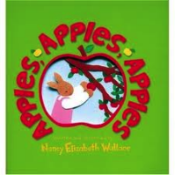 | 14  NO SCHOOL  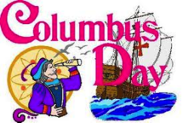 | 15  Phonics- Letter Ww  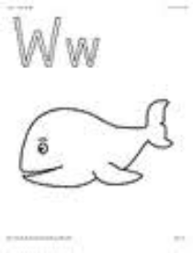 | 16  Math- Review 1-5  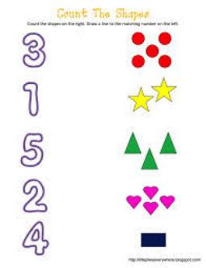 | 17  Cooking Experience- “Apple Salad”  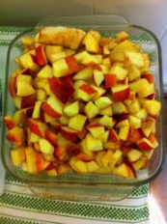 | 18  Science-“How an Apple Grows” 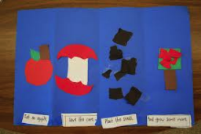  Music & Movement
Theme: “Apples and Pumpkins” 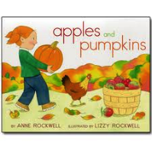 | 21  Phonics- Letter Nn  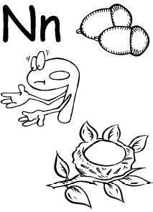 | 22  Arts & Crafts- Jack O Lantern  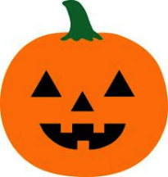 | 23  Math- Review 1-5  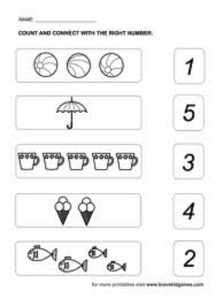 | 24  Science- Exploring the Inside of a Pumpkin  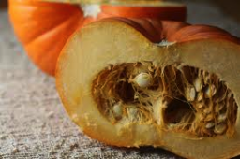 | 25  Trip  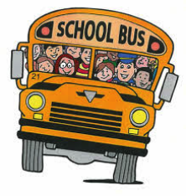
Theme: “I’m Not Scared”  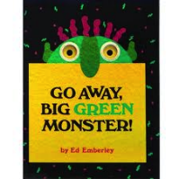 | 28  Phonics- Letter Xx  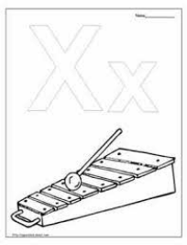 | 29  Arts & Crafts- Big Green Monster  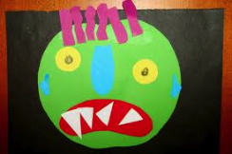 | 30  Math- Review 1-5  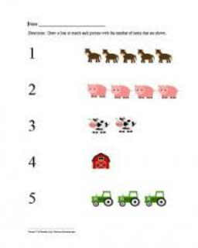 | 31  Language & Literacy- Creating a “Story Starter Book” about being brave.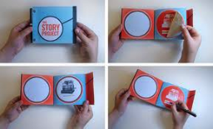 | Gym  Music & Movement

