◄ | ~ Toddlers Lesson Plan  October 2013 ~ Fall is Here
Theme | Mon | Tue | Wed | Thu | Fri
Leaves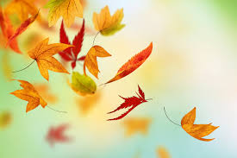 |  | 1 Color Leaves to illustrate the various fall colors.  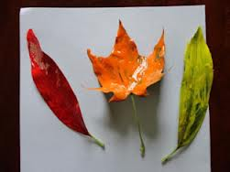 | 2 Create various types of leaves using construction paper.  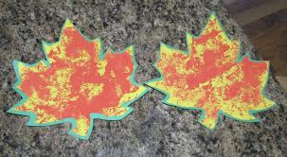 | 3 Leaf Wreath 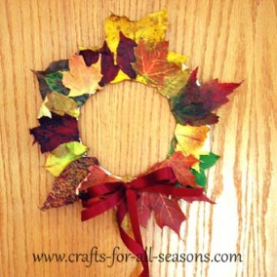 | 4 Go on a nature walk to observe the colors of the leaves on trees before they change. Collect leaves. Create a nature collage
Apples  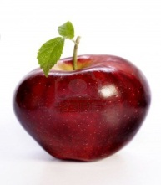 | 7 Create apples paste red tissue paper on the apples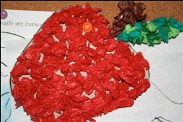 | 8 Apple Prints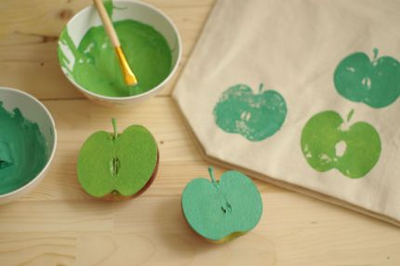 | 9 Hand Apple Tree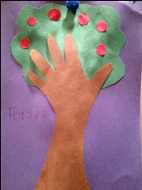 | 10 Hand Print Apple  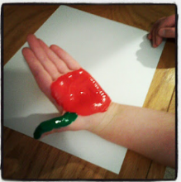  (Music & Dance 10:30am) | 11 Color the Apple Red, Paste on the popsicle stick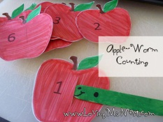
Number 2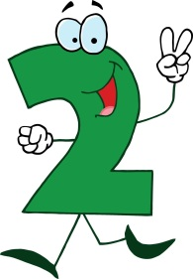 | 14 SCHOOL CLOSED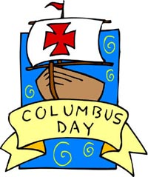 | 15 Color the number 2  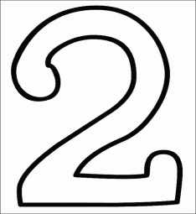 | 16 Color and Paste 2 circles. Count them  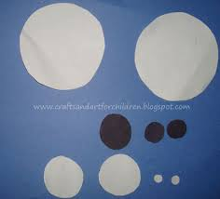 | 17 Identify 2 objects in the classroom. Count to 2. | 19 Create a #2 Book  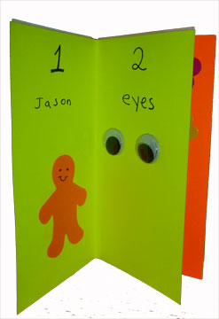
Harvest   | 21 Color the letter A. A for Acorn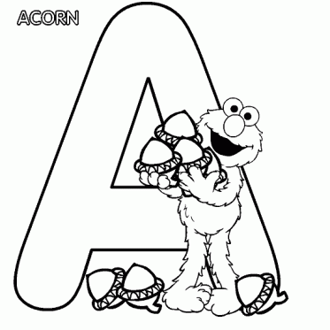 | 22 Paint an Acorn  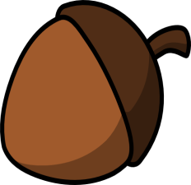 | 23 Create a pumpkin using construction paper. Paint the pumpkin.  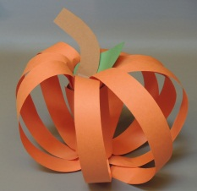 | 24 Color the Pumpkin orange paste on popsicle stick  (Music & Dance 10:30am) | 25 Trip to Pumpkin Patch  
Fall | 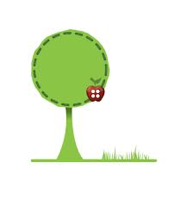  28 Color the tree green. Paste 2 Red Apple in a tree. Aa is for Apple | 29 Creating a tree using construction paper, paste leaves on the tree.  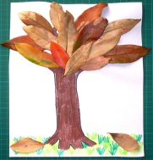 | 30 Fingerprint Fall Trees  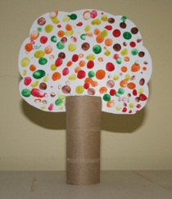 | 31 Fall Leaves Collage. 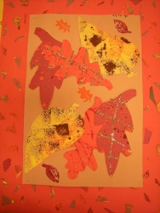 | 1 Story Book Character Party.  Please dress kids up in a costume pertaining to their favorite story book character

